* 

**S. B. JAIN INSTITUTE OF TECHNOLOGY, MANAGEMENT & RESEARCH, NAGPUR.**

**Practical No. 0 (Pre-Lab)**

**Aim:** Understand & create Github Repository account and add any HTML/CSS template website in it.

**Name of Student: Deepti Gudadhe**

**Roll No:AM21044**

**Semester/Year: 1 year**

**Academic Session: 2021- 22**

**Date of Performance: 05/05/22**

**Date of Submission: 18/05/22**

**AIM:**  Understand & create Github Repository account and add any HTML template website in it.

**OBJECTIVE/EXPECTED LEARNING OUTCOME:**

The objectives and expected learning outcome of this practical are:

* To know the working of Github platform.
* To know how to create account on Github platform.
* Able to add HTML template onGithub repository.

**THEORY:**

**What is Github?**

GitHub is a code hosting platform for collaboration and version control.

GitHub lets you (and others) work together on projects.

**Repository**

* A GitHub repository can be used to store a development project.
* It can contain folders and any type of files (HTML, CSS, JavaScript, Documents, Data, Images).
* A GitHub repository should also include a licence file and a README file about the project.
* A GitHub repository can also be used to store ideas, or any resources that you want to share.

**Branch**

* A GitHub branch is used to work with different versions of a repository at the same time.
* By default a repository has a master branch (a production branch).
* Any other branch is a copy of the master branch (as it was at a point in time).
* New Branches are for bug fixes and feature work separate from the master branch. When changes are ready, they can be merged into the master branch. If you make changes to the master branch while working on a new branch, these updates can be pulled in.

**Commits**

* At GitHub, changes are called commits.
* Each commit (change) has a description explaining why a change was made.

**Pull Requests**

* Pull Requests are the heart of GitHub collaboration.
* With a pull request you are proposing that your changes should be merged (pulled in) with the master.
* Pull requests show content differences, changes, additions, and subtractions in colors (green and red).
* As soon as you have a commit, you can open a pull request and start a discussion, even before the code is finished.

**Steps to install Github.**

1. Visit the download page for GitHub Desktop.
2. Click Download for Window.
3. In your computer's Downloads folder, double-click the GitHub Desktop zip file.
4. After the file has been unzipped, double-click GitHub Desktop.
5. GitHub Desktop will launch after installation is complete.

**How to create account on Github?**

**Open https://github.com in a web browser, and then select Sign up.**

1. Enter your email address.
2. Create a password for your new GitHub account, and Enter a username, too. ...
3. Verify your account by solving a puzzle. ...
4. After you verify your account, select the Create account button.

**Screenshots of Github Account:**

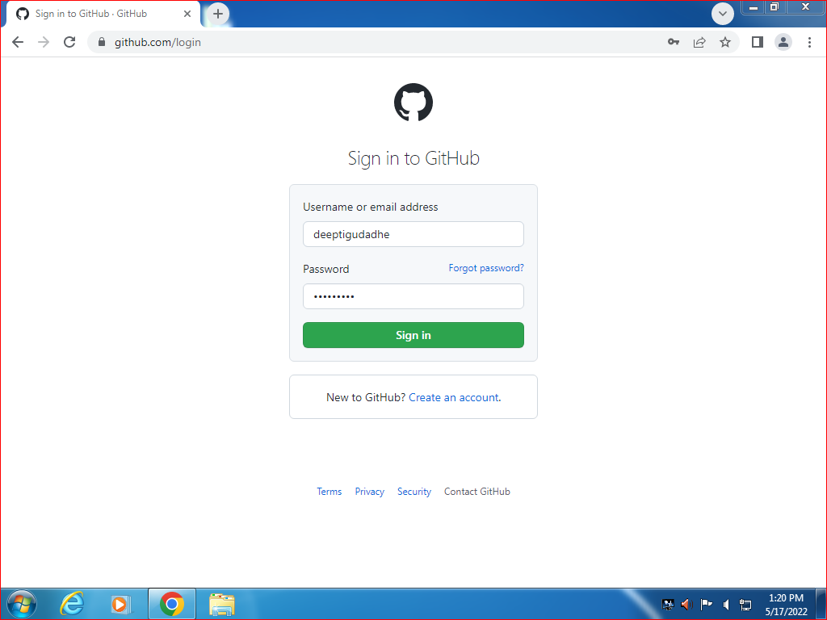

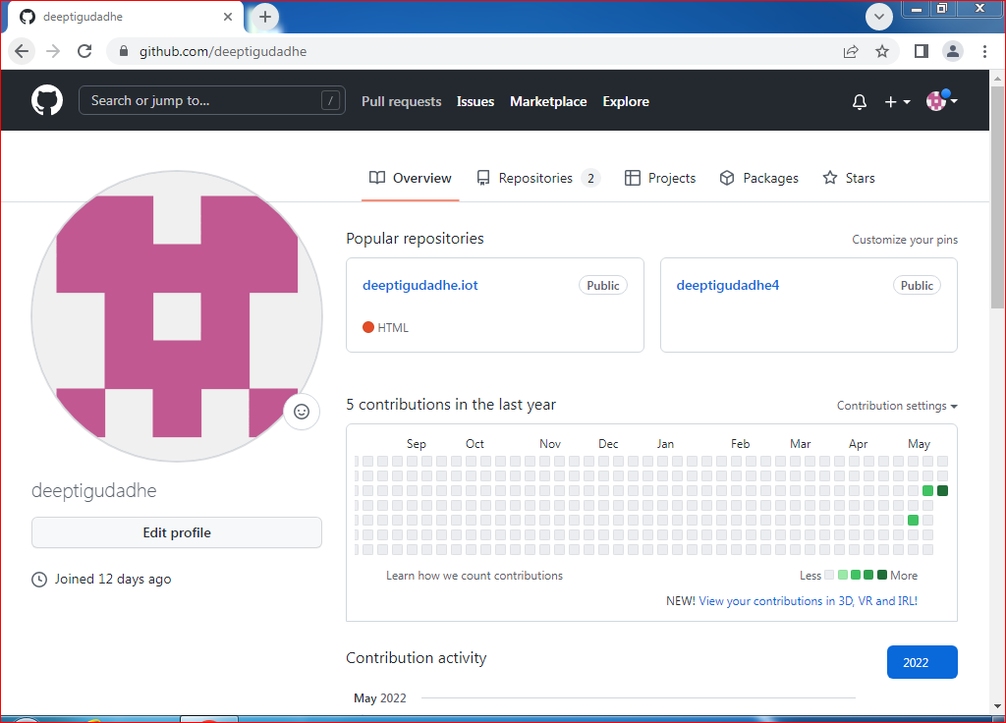

**Screenshots of adding files into repository:**

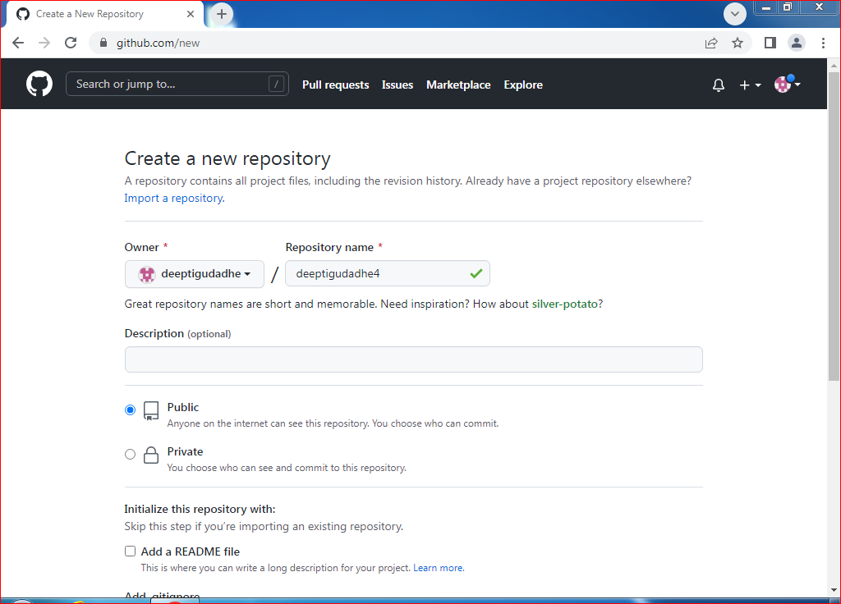

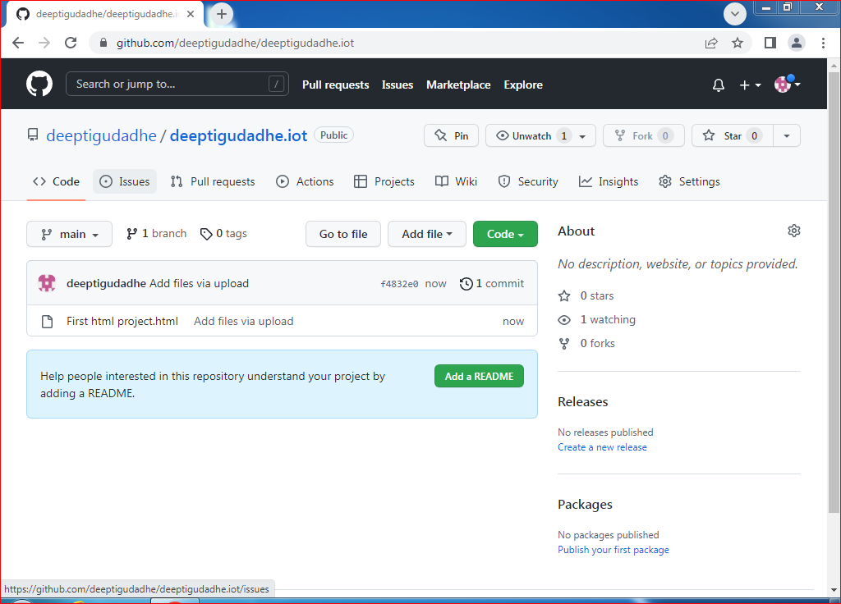

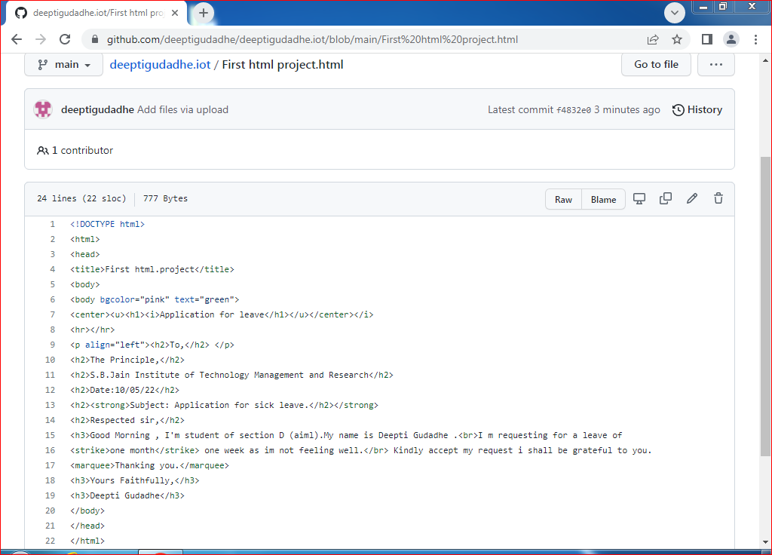

**CONCLUSION: GitHub is a code hosting platform for version control and collaboration . ot lets you and other work together on projects from anywhere. This tutorial teaches you GitHub essentials like repositories , branches ,commits and pulll requests.**

**DISCUSSION QUESTIONS:**

1. What is Github?
2. Define repository. How can you create repository on Github?
3. Explain pull request?
4. How much space do we get on Github?
5. What are the benefits of Github over other platforms?

**REFERENCE:**

* [*https://github.com/simplilearn-github*](https://github.com/simplilearn-github)
* [*https://www.youtube.com/watch?v=iv8rSLsi1xo*](https://www.youtube.com/watch?v=iv8rSLsi1xo)*.*
* [*https://www.codewithharry.com/videos/git-tut-beginners-hindi-1/*](https://www.codewithharry.com/videos/git-tut-beginners-hindi-1/)